Sample of PhysicalVerification Pictures.

The table below illustrates some physical status of the verified assets with photographic evidence.
Table XXX: Physical verification photos
AGANGA HC III MATERNITY | 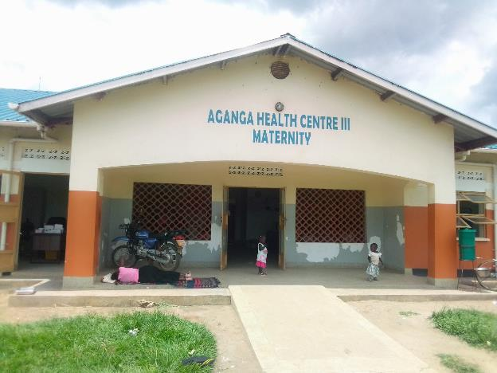
AGANGA HC III MATERNITY | 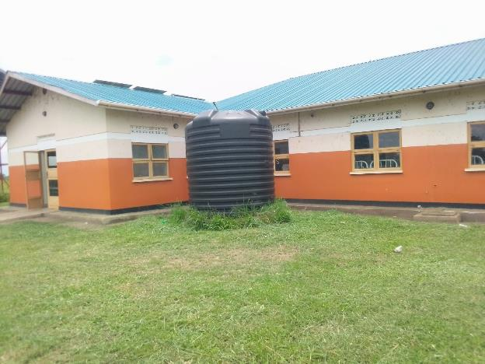
TYPICAL SET OF STAFF QUARTER’S BLOCK  (HOUSE BLOCK WITH TWO UNITS, KITCHEN AND TWO STANCE TOILET BLOCK) | 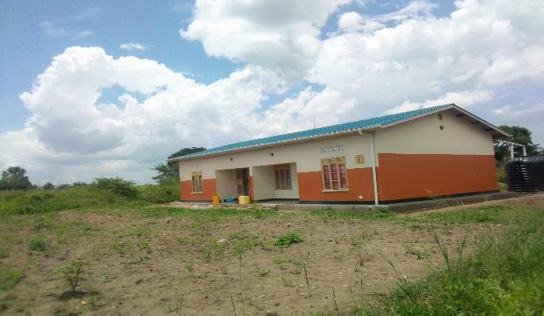
PLACENTA PIT | 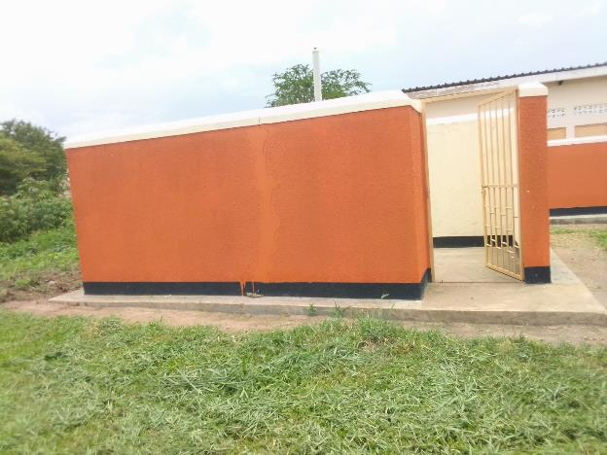
PLACENTA PIT | 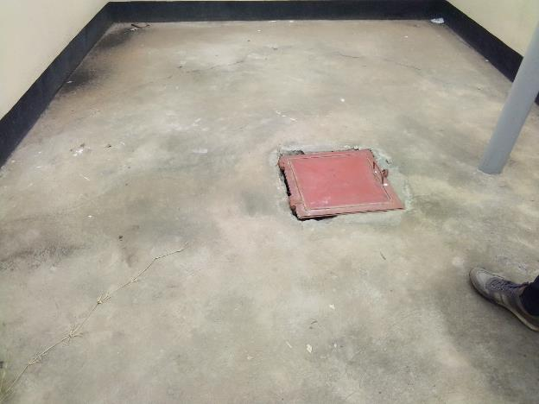
WATER TANK BEHIND MATERNITY | 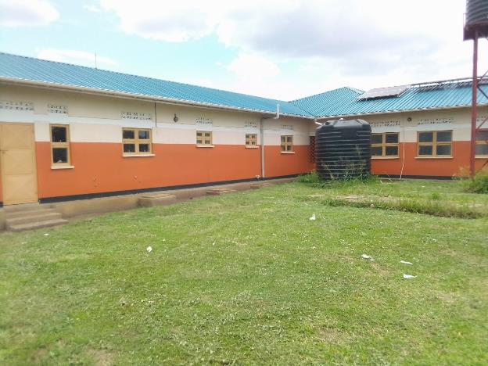
TOILETS | 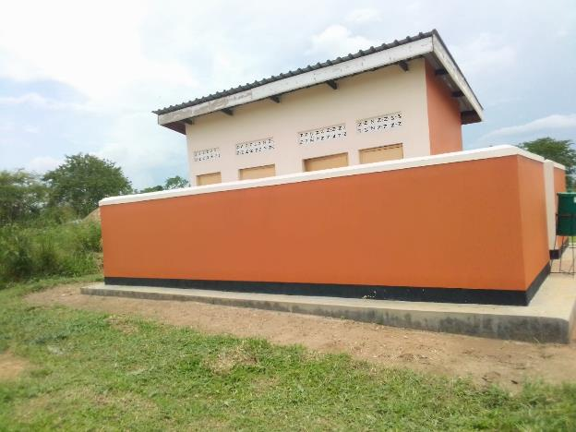
DELIVERY BED, HYDRAULIC MANUAL | 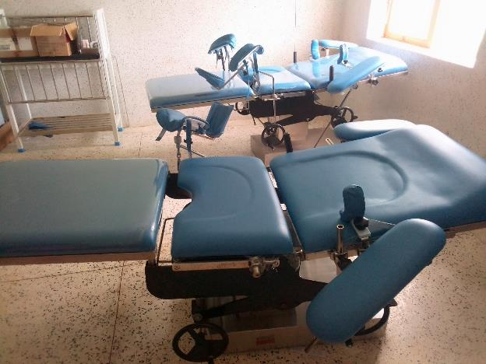
BED, PEDIATRIC PATIENT WITH MATTRESS | 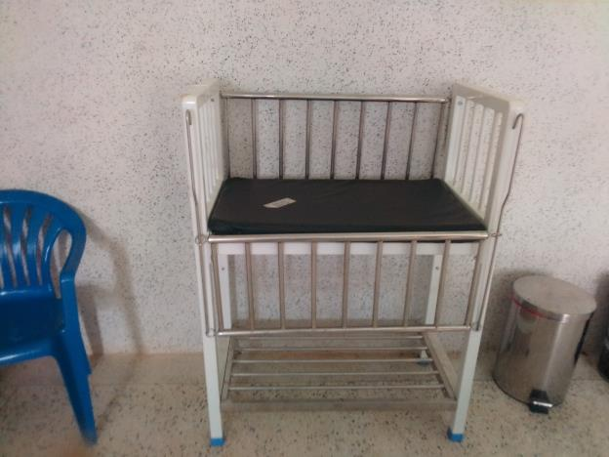
BP MACHINE, DIGITAL | 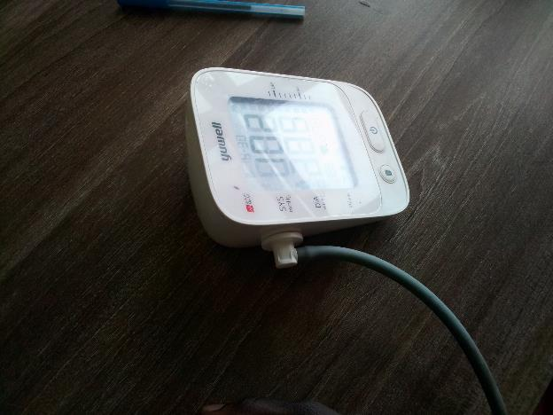
DESK | 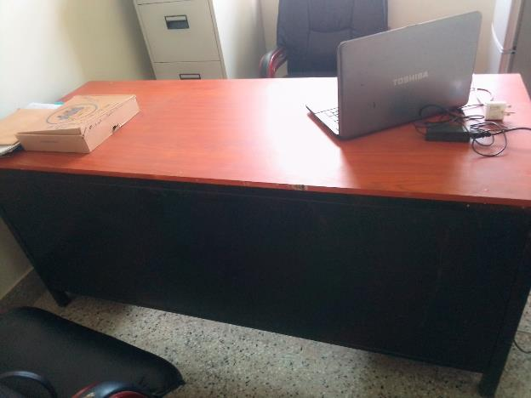
FILLING CABINET | 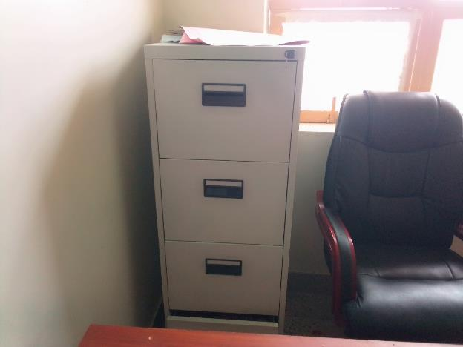
REFRIGERATOR, BASIC | 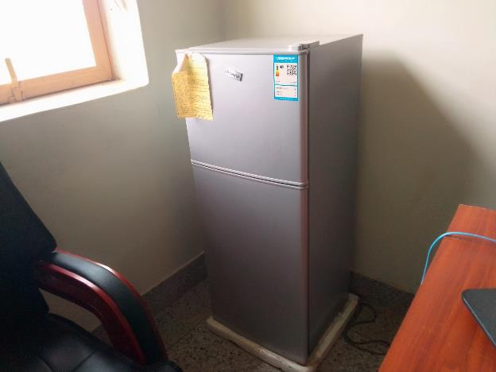
OFFICE CHAIR | 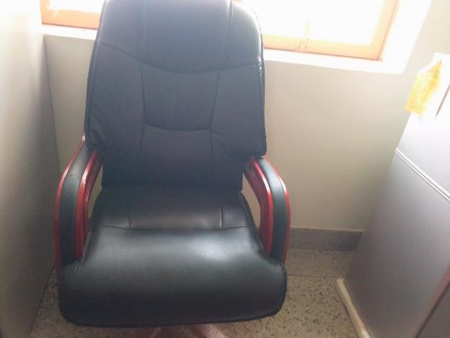
OXYGEN CONCENTRATOR | 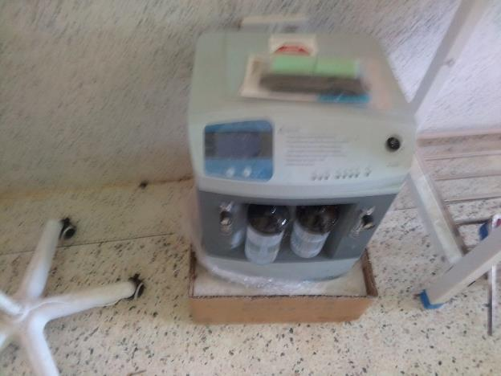
EXAMINATION LIGHT | 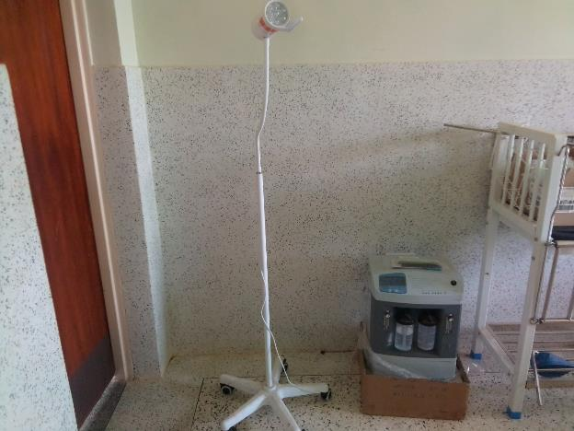
MICROSCOPE | 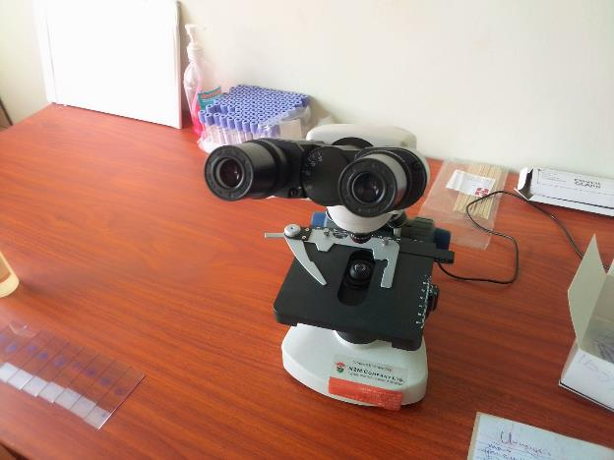
CENTRIFUGE (ELECTRIC) | 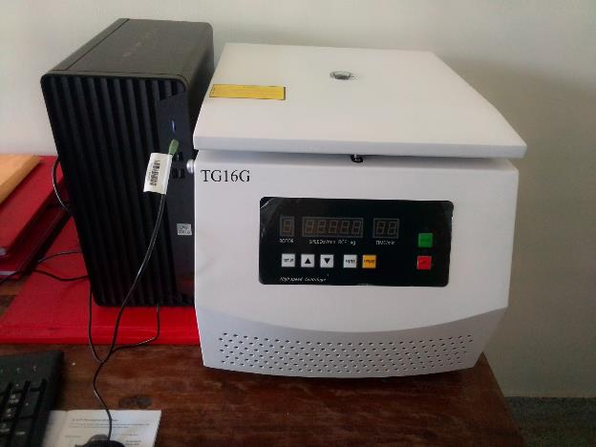
KANGAROO MOTHER CARE CHAIR | 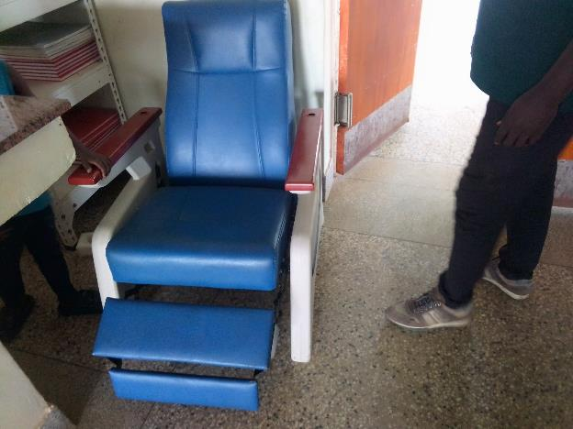
STRETCHER | 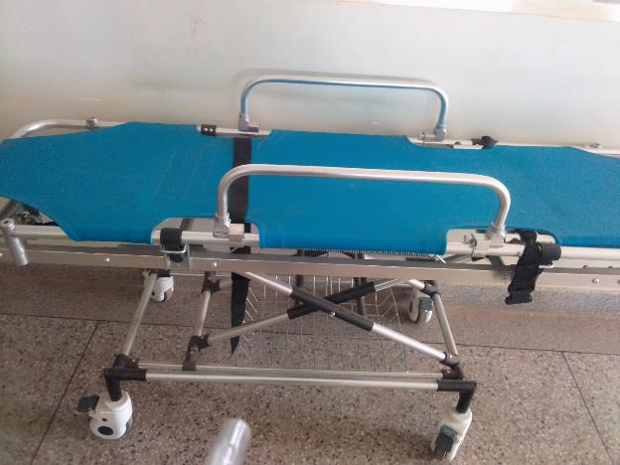
STRETCHER | 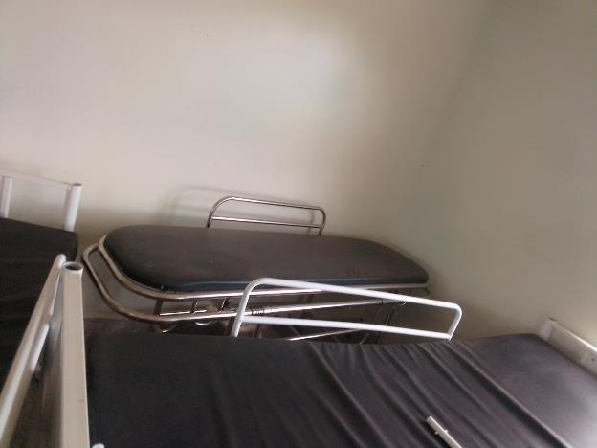
WHEEL CHAIR | 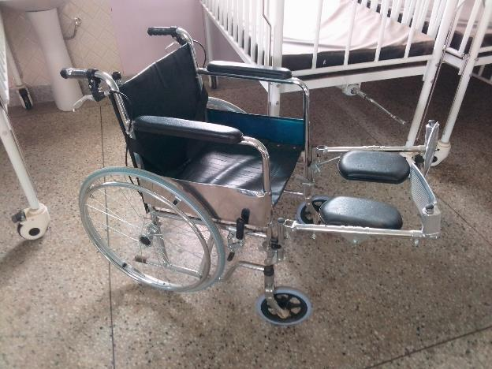
BED, ADULT PATIENT WITH MATTRESS | 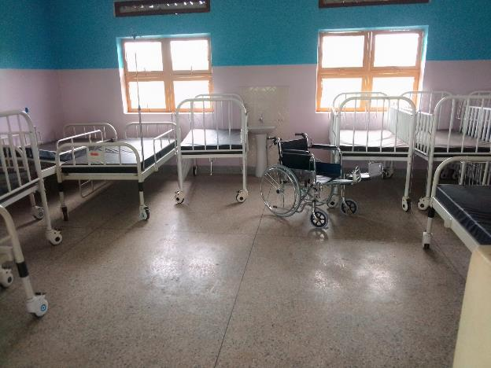
BED, ADULT PATIENT WITH MATTRESS | 